

**XL**

**Orthogonal-Frequency Division Multiplexing in LTE for data transmission**

**RI53 – Spring 2023**

Project Team :

**ALBUZLU Gökdeniz**

**KIEFFER Jérémy**

**MEZIANE Maryem**

**VAN AKEN Brice**

Project Manager :

**BAALA Oumaya**

|  |  |
| --- | --- |
|  |  |

# Abstract

The purpose of this project was to develop an enhanced standalone simulator for simulating OFDMA downlink data transmission in LTE networks from a single antenna to multiple user devices within a single cell. The simulator aimed to incorporate advanced features such as adaptive modulation and coding (AMC), interference management techniques like fractional frequency reuse (FFR) and inter-cell interference coordination (ICIC), as well as performance metrics and a graphical user interface (GUI).

The methodology involved an extensive literature review, defining the simulation architecture and functional blocks, and implementing the simulator using appropriate programming languages and libraries. The project focused on carrier allocation, asynchronous heterogeneous traffic data handling, and ensuring quality of service (QoS) guarantees for various traffic types.

The key results demonstrated that the enhanced simulator effectively modeled the OFDMA-based LTE data transmission process and accurately represented resource allocation, AMC, interference management, and performance metrics. Comparison with theoretical expectations, real-world scenarios, and existing simulation tools validated the simulator's effectiveness and reliability.

In conclusion, the Project-XL: Enhanced OFDMA-based LTE Data Transmission Simulator successfully achieved its objectives by incorporating state-of-the-art techniques and features. This advanced simulation tool can serve as a valuable resource for researchers, engineers, and network operators seeking to understand, design, and optimize OFDMA-based LTE systems. Future work may include extending the simulator to support multiple-input multiple-output (MIMO) antennas, incorporating machine learning algorithms for resource allocation, and simulating additional traffic types and scenarios.

Haut du formulaire

Bas du formulaire

# Introduction

The increasing demand for high-speed data services and seamless connectivity has driven significant advancements in wireless communication technologies. One such innovation is the use of Orthogonal Frequency Division Multiplexing Access (OFDMA) in Long-Term Evolution (LTE) networks. OFDMA enables efficient use of radio resources, robustness against channel impairments, and high spectral efficiency. However, developing and optimizing OFDMA-based LTE systems requires accurate modeling and simulation of network behavior, resource allocation strategies, and interference management techniques.

The motivation behind this project stems from the need for an advanced standalone simulator that can accurately represent OFDMA downlink data transmission in LTE networks from a single antenna to multiple user devices within a single cell. Such a simulator would help researchers, engineers, and network operators better understand, design, and optimize OFDMA-based LTE systems to meet the growing demands of modern wireless communication.

OFDMA is a multi-carrier modulation scheme that divides the available bandwidth into multiple orthogonal sub-carriers, each carrying a portion of the user data. LTE is a widely used standard for wireless communication, designed to provide high-speed data and improved network capacity. LTE employs OFDMA in the downlink transmission to achieve increased spectral efficiency, reduced latency, and better support for heterogeneous traffic.

The objective of this project is to develop an enhanced OFDMA-based LTE data transmission simulator that incorporates advanced features such as adaptive modulation and coding (AMC), interference management techniques like fractional frequency reuse (FFR) and inter-cell interference coordination (ICIC), as well as performance metrics and a graphical user interface (GUI). These extended features aim to provide a more comprehensive and realistic simulation of OFDMA-based LTE networks, enabling users to evaluate and optimize various network parameters and strategies effectively.

# List of Figures

Figure 1: development process 12

Figure 2: developpement Methods 12

# List of Tables

# Summary

Table des matières

Abstract 2

Introduction 3

List of Figures 4

List of Tables 5

Summary 6

Chapter I. Review 8

1. Introduction : 8

2. OFDMA-based LTE Systems : 8

3. Simulation Techniques : 8

4. Adaptive Modulation and Coding (AMC): 8

5. Interference Management: 9

6. Performance Metrics: 9

7. Conclusion: 9

Chapter II. Methodology 10

1. Introduction : 10

2. Simulation Architecture and Functional Blocks: 10

3. Algorithms and Techniques : 10

4. GUI and Visualization Implementation : 11

5. Project Management and Leadership : 12

5.1. Project Management : 12

5.2. Software Quality: 12

5.3. Software Methodology: 14

5.4. Project Planning: 14

Chapter III. Analysis and Implementation 16

1. Introduction : 16

2. Choice of Programming Language, Libraries, and Tools: 16

3. Structure of the Source Code: 16

4. Design and Analysis: 16

5. Interfaces: 16

6. Conclusion : 16

Conclusion 17

References 18

# Chapter I. Review

## Introduction :

OFDMA-based LTE systems have been extensively studied in the literature, with various research works focusing on different aspects of the technology. This literature review provides an overview of the relevant research, simulation techniques, and state-of-the-art features in OFDMA-based LTE systems, as well as the theoretical foundations of adaptive modulation and coding, interference management, and performance metrics.

## OFDMA-based LTE Systems :

Numerous studies have examined the performance of OFDMA in LTE networks, highlighting its advantages in terms of spectral efficiency, reduced latency, and flexibility in handling diverse traffic types. Research on OFDMA has led to the development of efficient resource allocation algorithms, improved channel estimation techniques, and enhanced synchronization methods. Moreover, several papers have investigated the integration of OFDMA with other advanced techniques, such as multiple-input multiple-output (MIMO) and cooperative communication, to further enhance the performance of LTE networks.

## Simulation Techniques :

Simulation plays a crucial role in the design and optimization of wireless communication systems. Various simulation tools and frameworks have been proposed for OFDMA-based LTE networks, including open-source platforms like ns-3 and OMNeT++, as well as commercial solutions like MATLAB and OPNET. These tools offer varying levels of complexity and realism, with some focusing on high-level network performance evaluation and others providing detailed models of the physical layer and radio resource management.

## Adaptive Modulation and Coding (AMC):

AMC is a technique that dynamically adjusts the modulation and coding schemes based on the channel conditions to maximize throughput while maintaining a target error rate. Theoretical foundations of AMC involve the calculation of the channel capacity and the selection of the optimal modulation and coding scheme based on the signal-to-noise ratio (SNR) or other channel quality metrics. Several research works have explored AMC in OFDMA-based LTE systems, proposing efficient algorithms for optimal resource allocation and link adaptation.

## Interference Management:

Interference management is crucial for ensuring the efficient operation of OFDMA-based LTE networks, particularly in dense deployments. Key interference management techniques include fractional frequency reuse (FFR) and inter-cell interference coordination (ICIC). FFR involves the partitioning of the available spectrum into different frequency bands and assigning them to cells in a manner that reduces co-channel interference. ICIC, on the other hand, focuses on coordinating the resource allocation between neighboring cells to mitigate interference. Various studies have proposed and analyzed FFR and ICIC schemes for OFDMA-based LTE systems, demonstrating their effectiveness in improving network performance.

## Performance Metrics:

Performance metrics play a vital role in evaluating the efficiency of wireless communication systems. In OFDMA-based LTE networks, key performance metrics include throughput, delay, packet loss rate, and resource utilization. These metrics provide insights into the effectiveness of resource allocation algorithms, interference management techniques, and other network optimization strategies. Numerous studies have utilized these performance metrics to compare different approaches and identify the best practices for OFDMA-based LTE system design.

## Conclusion:

the literature on OFDMA-based LTE systems covers a wide range of topics, from fundamental concepts to advanced features and optimization strategies. This rich body of research provides valuable insights and guidance for the development of an enhanced OFDMA-based LTE data transmission simulator, incorporating state-of-the-art techniques and features.

# Chapter II. Methodology

## 1. Introduction :

The simulator aims to provide a comprehensive and interactive environment for the analysis and optimization of various systems and processes. By leveraging state-of-the-art computational techniques and user-friendly interfaces, our simulator enables researchers, engineers, and practitioners to test, validate, and enhance their designs effectively and efficiently.

## 2. Simulation Architecture and Functional Blocks:

The simulation architecture can be divided into several functional blocks to represent different aspects of the OFDMA-based LTE system. Key functional blocks include:

* System Initialization: Sets up the simulation parameters such as the number of user devices, available sub-carriers, sub-frames, and modulation and coding schemes.
* Channel Modeling: Simulates the wireless channel conditions between the base station and user devices, accounting for factors such as path loss, fading, and shadowing.
* Carrier Allocation: Allocates radio resources to user devices based on their traffic requirements and channel conditions.
* Adaptive Modulation and Coding (AMC): Adapts the modulation and coding schemes for each user device according to their channel quality.
* Interference Management: Implements FFR and ICIC techniques to mitigate interference and improve network performance.
* Quality of Service (QoS) Management: Ensures that different traffic types receive appropriate QoS guarantees.
* Performance Metrics Calculation: Computes throughput, delay, packet loss rate, and resource utilization metrics for the simulated network.
* Graphical User Interface (GUI) and Visualization: Provides an interactive interface for configuring the simulation parameters and visualizing the simulation results.

## 3. Algorithms and Techniques :

Various algorithms and techniques can be employed for carrier allocation, AMC, FFR, ICIC, and QoS guarantees:

* Carrier Allocation: Resource allocation algorithms, such as greedy algorithms, proportional fair scheduling, or game-theoretic approaches, can be used to assign sub-carriers and sub-frames to user devices.
* AMC: Link adaptation algorithms that select the optimal modulation and coding scheme based on the channel quality indicators (CQIs) reported by user devices can be implemented.
* FFR: Frequency bands can be partitioned and assigned to cells in a pattern that minimizes co-channel interference while maintaining overall network performance.
* ICIC: Techniques like soft frequency reuse (SFR) or coordinated scheduling can be applied to manage resource allocation between neighboring cells, reducing inter-cell interference.
* QoS Guarantees: Traffic-aware scheduling algorithms that prioritize traffic types based on their QoS requirements, such as delay sensitivity or minimum rate guarantees, can be employed.

## 4. GUI and Visualization Implementation :

A user-friendly GUI can be developed using popular libraries or frameworks, such as Qt or tkinter, depending on the programming language used for the simulator. Key visualization features may include:

* Resource Allocation Matrix: A graphical representation of the sub-carriers and sub-frames allocated to different user devices, with distinct colors to differentiate between various communications.
* Channel Quality Visualization: A heatmap or bar chart displaying the channel quality for each user device.
* Performance Metrics: Graphs or plots illustrating the throughput, delay, packet loss rate, and resource utilization for the simulated network over time.
* Configuration Panel: Interactive widgets for setting the simulation parameters, such as the number of user devices, traffic types, and simulation duration.

## 5. Project Management and Leadership :

Project management is an approach aimed at organizing the smooth running of a project from start to finish. When project management involves a set of projects contributing to a common goal, it is called program management.

In practice, the project is focused on the final objective and must be adaptable to frequent changes while being controlled and planned. Therefore, any modification must remain planned. In particular, the project must remain dynamic and continuously balance technical constraints and deadlines.

### 5.1. Project Management :

In our case, we were tasked with managing two major constraints: delivering a quality product and delivering on time. Given these constraints, our objectives, and the characteristics of our mission, we opted for the SCRUM methodology with good XP practices to manage our project. The choice of this approach was based on dividing the project into several iterations. At each iteration, a part of the project would be addressed, and at the end, the iteration must be delivered.

### 5.2. Software Quality:

Software engineering proceeds through several stages in the development of a computer program. This ensures the quality of the product and meets the needs of the user while respecting the deadlines set at the beginning.

Thus, our application must meet the main factors of software quality:

• **Validity**: the ability of the software to perform exactly the tasks specified during its specification.

• **Reliability and robustness:** the software's ability to operate continuously and even in abnormal conditions.

• **Compatibility**: the software must be easily combined with other software.

• **Reusability**: the application must be usable in its entirety or in part in another project.

• **Efficiency**: the software must be able to effectively use hardware resources.

• **Extensibility**: the software must be easy to maintain and able to accept the addition of new features.

• **Portability**: the software must be able to run on multiple different environments.

• **Integrity**: the software must be able to effectively protect its entire code or part of its code against unauthorized access.

To ensure software quality, it is necessary to master the software development process. To achieve this, we have to :

• Identified the objectives to be achieved.

• Defined the process (defining the activity and set of activities that use resources to convert input elements into output elements that have added value).

Ultimately, the quality of the development process is the guarantee of the quality of the product.

a. Activity and software development process:

A development process is carried out based on the concept of divide and conquer. It refers to the set of coordinated and regulated activities, partially ordered, whose goal is to create a product.

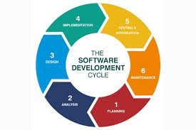

Figure 1: development process

In our case and generally in software development projects, the activities are common:

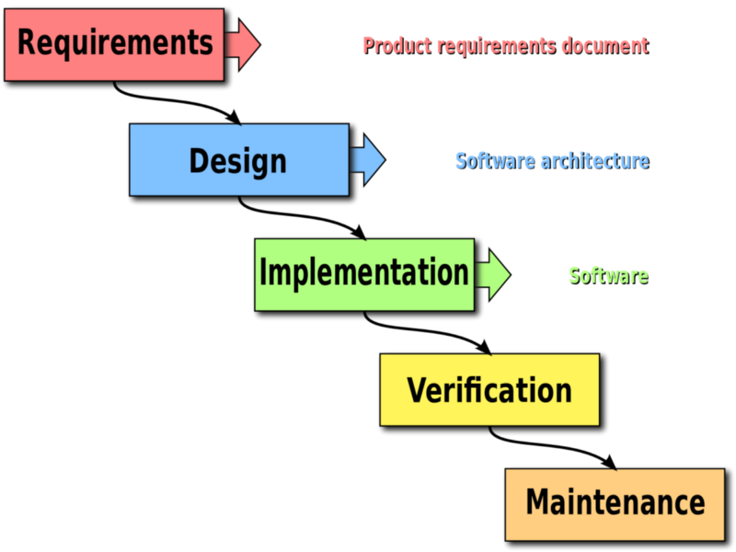

Figure 2: developpement Methods

### 5.3. Software Methodology:

To ensure the smooth progress of its different phases, we opted for a V lifecycle due to its risk management, iterative and incremental nature, and its simplicity of integration with the agile Scrum methodology for the design and development of our system. Scrum also adapts perfectly to project decomposition and is based on the following advantages:

• Greater flexibility and responsiveness.

• Great adaptability to ensure that the implemented application can meet new requirements during development.

• Best possible satisfaction of the client's (user's) needs.

• Iterative and incremental: the project will be divided into incremental units called iterations. The development time for each iteration is short (about two weeks), fixed, and strictly respected.

### 5.4. Project Planning:

After defining the specifications to specialize the Product Backlog, we chosed to divide the project implementation into 6 sprints of varying sizes ranging from one to two weeks each.

The project will be planned as follows:

|  |  |
| --- | --- |
| Sprint 1 | * Set up development environment and project structure. * Implement basic HTML/CSS layout for the simulator interface. * Implement Simulator class with initializeMatrix() and allocateResources() methods |
| Sprint 2 | * Implement newCommunication() method in the Simulator class * Implement displayInformation() and updateTimeProgression() methods in the Simulator class * Add help text and tooltips to the interface |
| Sprint 3 | * Add export functionality for simulation results in CSV, JSON, and Excel formats * Implement history of previous simulations and comparison of results |
| Sprint 4 | * Add navigation bar with links to Home, Documentation, and Information pages |
| Sprint 5 | * Add functionality to customize the number of sub-carriers and sub-frames in the simulation * Add option to choose from different coding schemes for new communications. |
| Sprint 6 | * Bug fixing and testing * Final polish of the user interface * Prepare for deployment and release of the application. |

Note: The duration of each sprint is approximate and may vary depending on the progress made during each sprint. The exact order of implementation of some features may also change depending on the needs and priorities of the project.

6. Conclusion :

By combining these methodologies, the enhanced OFDMA-based LTE data transmission simulator will provide a comprehensive and realistic representation of network behavior, enabling users to evaluate and optimize various network parameters and strategies effectively.

# Chapter III. Analysis and Implementation

## 1. Introduction :

## 2. Choice of Programming Language, Libraries, and Tools:

## 3. Structure of the Source Code:

## 4. Design and Analysis:

## 5. Interfaces:

## 6. Conclusion :

# Conclusion

# References